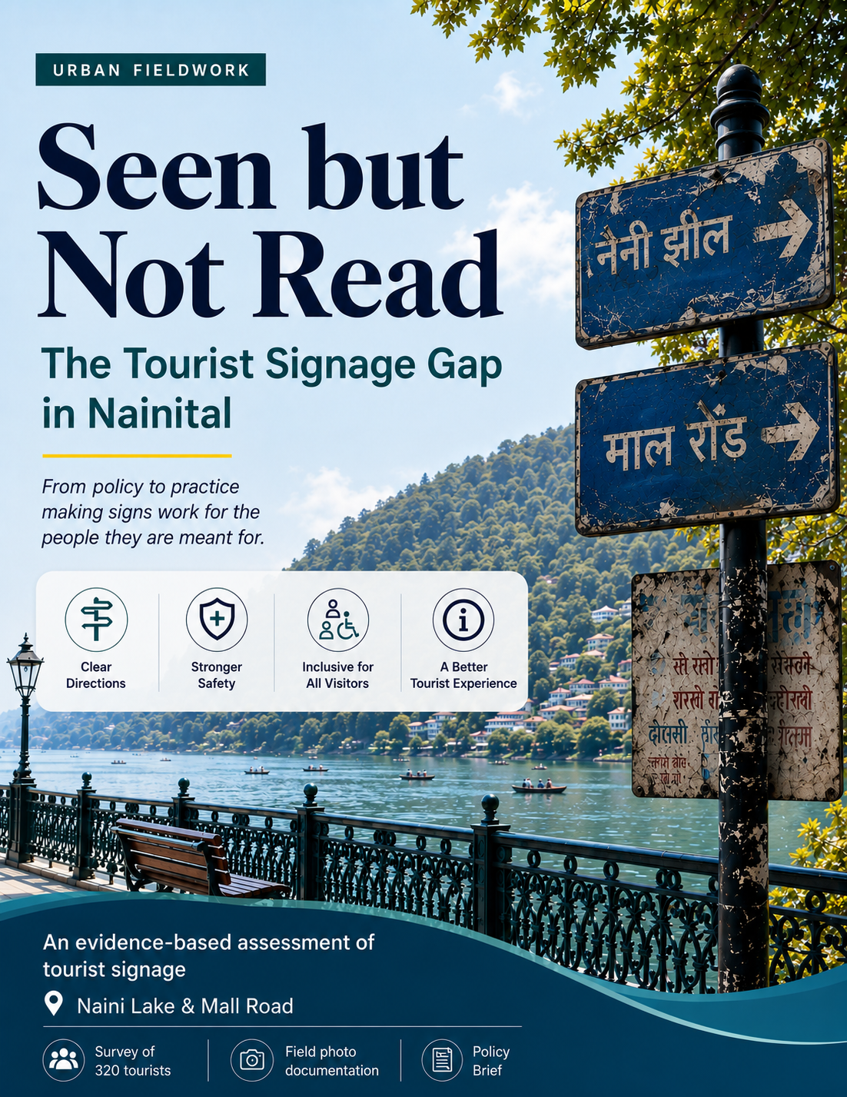

Table of Contents

1 Executive Summary
2 Introduction and Background
2.1 Tourism Growth in Uttarakhand
2.2 Nainital as a Tourist Destination
2.3 Importance of Tourist Signage
2.4 Uttarakhand Tourism Policy 2023
2.5 Study Focus and Scope
3 Research Approach and Fieldwork
3.1 Study Area: Naini Lake and Mall Road
3.2 Tourist Survey
3.3 Sample Size and Respondents
3.4 Photographic Field Observation
3.5 Analytical Approach
4 Key Issues in Tourist Signage
4.1 Signage Availability vs Signage Effectiveness
4.2 Visibility and Placement
4.3 Language and Bilingual Accessibility
4.4 Readability and Legibility
4.5 Accessibility and Inclusiveness
4.6 Safety and Emergency Information
4.7 Lack of Precinct Maps and Wayfinding
5 Evidence from the Field
5.1 Tourist Perceptions of Directions and Signboards
5.2 Signboard Usefulness and Tourist Satisfaction
5.3 First-Time vs Repeat Visitors
5.4 Field Observation: Two Tiers of Signage
5.4.1 Well-Maintained Signage
5.4.2 Neglected Signage
5.5 Missing Safety and Emergency Signage
5.6 Absence of Precinct Maps
5.7 Advertising vs Tourist Information
5.8 Waste-Segregation Signage
6 Policy Commitments vs Ground Reality
6.1 Bilingual Signage Requirement
6.2 Braille and Inclusive Signage
6.3 Waterbody Safety Requirements
6.4 Implementation and Monitoring Gap
7 Policy Recommendations
7.1 Establish a Standardised Tourist Signage System
7.2 Make Tourist Signage Inclusive and Safety-Oriented
7.3 Develop a Continuous Pedestrian Wayfinding Network
7.4 Introduce a Baseline Inventory and Signage Audit
7.5 Establish Accountability and Visitor Reporting
7.6 Require Pictograms on Safety-Critical Signage
8 Policy Direction and Implementation Framework
8.1 From Isolated Signboards to an Integrated Information System
8.2 Standardisation and Accessibility
8.3 Monitoring and Accountability
8.4 Priority Areas for Implementation
9 Conclusion
10 References

GROUP 3:

Yug Bhogi : m2024bsass008
Jayadtiya Sharma: m2024bsass012
Riya Rao: m2024bsass023
Shubha Varma: m2024bsass029
Seen but Not Read: The Tourist Signage Gap in Nainital

Executive Summary

Go for a walk on a weekend at Naini Lake, and you will find signboards all around the lake. It's as though there's a pattern; look closer. Signs in government offices or that collect parking charges are clear, in two languages, and in the correct location. The signs a tourist needs to rely on, the now-omission of warning signs, directing signs, or explaining a rule, are often dull, written in Hindi exclusively, covering a parked car with leaves, or just in short supply. There's no lack of signage. However, it simply isn't working for the people it's supposed to work for.

This brief delves into the disconnect between the provisions of the Uttarakhand Tourism Policy 2023 and the ground realities. The policy calls for signs to be available in two languages (Hindi and English, with a focus on Hindi) for directions, information, description and safety reasons. However, safety signs will be more prevalent at high-risk locations such as water bodies, and descriptive signs will be in Braille. To see if those pledges are upheld, we rely on a survey of 320 tourists and on photo-prospection throughout the precinct at Naini Lake and Mall Road. To test such a commitment, we first rely on a tourism survey conducted at Naini Lake and Mall Road, with a sample of 320 tourists, and simultaneously conduct photo-prospection of all the precincts.

The survey puts the price on the blinds. There is a positive and significant correlation between the perceived usefulness of signboards and overall satisfaction (r = .321, p < .001): tourists who did not perceive signboards as useful had a clear reduction in satisfaction with their overall visit. The most GPS-expensive - first-time visitors - did not see it as high as the repeat visitors who have already encountered the town in person. The field photographs tell us that's why. No precinct maps are posted at any main entrance, no Braille signage is posted anywhere, and no signage regarding emergencies and hazards is posted in the boating areas, which 75% of surveyed tourists used.

Certainly, it is not a policy design problem, but it's an implementation and monitoring problem at the destination level. The report proposes a consistent signage system, a safe and inclusive design, an integrated pedestrian wayfinding system, regular signage audits with an appropriate baseline inventory, and pictograms on all safety-critical signage. All of these would help turn commitments on paper into signed, barefoot, strapped, or tatted-up commitments that are maintained, accounted for, and actually useful.

Background and Context
The tourism industry in Uttarakhand has experienced rapid growth, with the number of tourists visiting the state rising from 2 crore to 6.03 crore between 2021 and 2025 (ETV Bharat, 2026). The Uttarakhand Tourism policy document also sets ambitious goals, with expectations that tourism will contribute 15% to the Gross State Domestic Product (GSDP) and generate USD 10 billion in annual revenue by 2030 (Uttarakhand Tourism Development Board [UTDB], 2023).
The town of Nainital is among the cities benefiting from such growth. The town centres on Naini Lake, which is sacred to the Naina Devi temple and serves as the town's recreational area, and continues to draw huge crowds of visitors. Recent reports have indicated 'heavy footfalls' in Naini Lake and Mall Road during weekends, with the local administration struggling to cope with the congestion (ANI, 2026; Republic World, 2026). Nainital, being among the state's tourism Gateway Hubs, is expected to see an increase in visitor numbers (UTDB, 2023).
All these visitors strain basic facilitation infrastructure, and one of the most straightforward and economical components of this infrastructure is signage. Proper directional and safety signs will help visitors locate parking spaces, boating areas, and viewing points, and avoid danger zones near the water, without which they will have to resort to guesswork or the advice of touts.
According to the records, the government understands the importance of these signs, too. Following policies made in 2001 and 2018, the present Tourism Policy was notified on 6 April 2023, and will be valid for the next seven years (Uttarakhand Paryatan Vikas Parishad, 2023). The policy promises to provide proper directional, informative, descriptive, and safety signs "...in Hindi and English language, at multiple points," with "Braille inscription in descriptive signage" (UTDB, 2023, p. 38), and "signage and patrolling in accident-prone areas such as viewpoints at hill stations, waterbodies..." (UTDB, 2023, p. 47), among others, directly applicable to Nainital.
Our urban fieldwork data suggest this commitment isn't fully evident on the ground. In our survey of tourists at Naini Lake and Mall Road, ratings for ease of navigation were (3.75/5), while signboard usefulness was rated (3.46/5), middling at best. Several respondents reported missing, unclear, or poorly placed signboards, especially away from the main road. This brief draws on that tourist survey (n = 320) and photographic field observations of signage across the precinct.
This gap between what the policy promises and what tourists actually experience is the focus of this study. We focus on signboards around the Naini Lake precinct, their presence, placement, and condition, as our lens into this wider policy-implementation gap, leaving out other parts of the tourist experience, such as accommodation, transport, or pricing.
This was part of the Urban Immersion fieldwork, which aimed to assess sustainable tourism in Nainital by analysing it from environmental, social, and economic perspectives. Data collection was conducted using five methods: a resident survey of 233 participants, a tourism worker survey of 292 participants, a tourism enterprise survey of 154 participants, a tourist survey of 320 participants, and a location-based field observation tool for 10 locations. These different tools gave the fieldwork a chance to study sustainable tourism from different angles and perspectives.

Key Issues
The main field problem was not about the lack of tourist information infrastructure but its effectiveness. In Nainital, field observations and survey evidence converge on a particular pattern – the presence of signage, but limited use due to its placement, language, and legibility, as required by tourists.

The Uttarakhand Tourism Policy 2023 emphasises providing greater convenience to visitors and sharing information within Uttarakhand's tourism framework. It emphasises the need for seamless travel, in which all tourist points provide convenience, comfort and safety. The policy stipulates the use of Language Informative Signs, Directional Signs, Descriptive Signs (with Braille), and Safety Signs in different areas. It also highlights the need for signs at significant locations for tourists. Also, the policy states that there should be signage and patrols in accident-prone areas, such as near bodies of water. It also involves providing emergency information and assistance to tourists (UTDB, 2023). Lack of a policy framework is not a problem in Nainital. It is in the poor report of these guidelines in the translation into consistent practice at the destination level. This clearly highlights the need for agencies managing tourism infrastructure and local destination management to implement and monitor this.

From the tourist survey, it can be observed that a navigation concern occurs. The mean score for ease of finding directions was 3.76. The mean score for signboard usefulness was 3.46. Perhaps even more important, there was a statistically significant correlation between usefulness and overall satisfaction among signboard users. The usefulness of signboards with overall satisfaction is positively correlated (r = .324, p < .001). The average satisfaction of tourists who rated signboards 1 or 2 was 3.40. The average satisfaction among those who rated signboards 4 or 5 was 4.08. This actually gives us good insight into how people perceive signage, which in turn affects their overall experience at the destination.
The data thus highlight that the availability and accessibility of signage are only part of the problem; whether it offers useful information where visitors need it is the other part.

The second one concerns the delivery of the information and its location. It turns out that the signs are primarily located in the main Naini Lake area, and the number of signs decreases as you follow the side of the Mall Road. Some boards are not easily read, are blocked from a visitor's perspective, or are placed where a visitor is likely to need to make a decision. This results in signage that may be present but does not effectively support navigation. The significance of physical signage and its positioning also reinforces, from within the existing body of literature, the benefits of such in assisting tourists in navigating the area and creating the tourist experience. Research into tourist signage has examined the impact of adopting a wide range of models, looking at how guides or signs lead visitors through unfamiliar environments to tourist facilities. Signage is particularly important in instances involving numerous turnings and/or new or unfamiliar routes, as a lack of visibility, location, and accessibility affects the experience, as observed by Wan (2024). Moreover, a few recent studies conducted in urban tourism in India show that information about tourism sites, events, and nearby locations can contribute to tourists' satisfaction and the overall destination experience (Mitra, 2024). The author also goes on to emphasise the relationship between aspects of effective wayfinding, namely the “visibility”, “readability”, “understandability”, “language” and “layout.” Even if the sign is available, bad placement, obscured view or name inconsistencies can make information hard to find. (Moosavi & Balraj, 2013). The same research also suggests the significance of language and uniform visual presentation of signs for travellers to understand them.

The overall picture indicates that it is a destination management problem. Nainital has only created policy options for providing tourist information. However, these policies have yet to be translated into a traveller information system that is continuous, visible, and accessible throughout the tourist journey. The policy issue is not about providing more signboards but rather about the consistency of the information, its location, and accessibility and usability of all the tourist information infrastructure.

Evidence from the Field

What the survey tells us
At Naini Lake and Mall Road, the number of signs received from tourists was 2 at each location, all of which were direct signs. Directions were easy to find, with a Mean of 3.75 on a 5–point scale. The mean of perceived usefulness of the signboard was 3.46. 63 per cent gave it a rating of 4 or 5 for ease of directions, and 9 per cent rated it 1 or 2. These scores, if they were to stand alone, wouldn't be dire; they would be middle-of-the-pack scores.

The 2nd rating considered, signage on the visit, becomes more meaningful when compared to overall satisfaction with the destination. The two are positively and significantly correlated (r = .321, p < .001, n = 263).
Table 1. Overall satisfaction with Nainital, by signboard usefulness rating
Signboard usefulness rating | Mean satisfaction (out of 5) | n
1 or 2 (low) | 3.40 | 43
3 (middle) | 3.62 | 86
4 or 5 (high) | 4.07 | 134

A second cut sharpens the picture. First-time visitors, the group most reliant on physical wayfinding, rated signboards lower than repeat visitors who are already familiar with the town.
Table 2. Signboard usefulness rating, by visit history
Visit history | Mean signboard usefulness | n
First-time visitors | 3.34 | 152
Repeat visitors | 3.61 | 117

The third angle reveals the essence of the problem. The respondents to both questions were the same tourists, and their responses are not at all in sync. People give higher ratings to information about directions than to the signboards themselves. Put another way, visitors are travelling, but signage isn't necessarily.
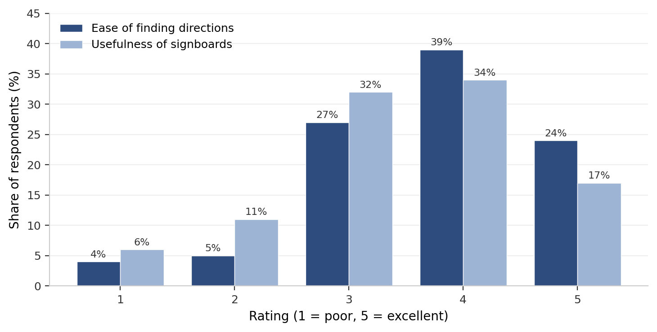
Figure 1. How tourists rate ease of finding directions versus usefulness of signboards (n = 320)
The trait is most clearly differentiated at the high end of the scale. The proportion of tourists giving directions a score of 4 or 5 is 63 per cent, whereas for signboards it is 51 per cent; 17 per cent of tourists rate signboards with the highest score of 5, compared to 24 per cent for directions. That also results in more signboards receiving lower scores, as 17 per cent of respondents rate signboards 1 or 2, compared with 9 per cent for directions. While part of the job is being done, visitors appear to be using other signs to help them navigate, setting the table for a good signage system.

Two tiers of signage on the ground
From our field photographs, it is evident that there is a significant division in the quality of signs within the precinct. Well-constructed and well-cared-for building. The other isn't, and the line that divides them marks the subjects of the signs.

Well-maintained tier.
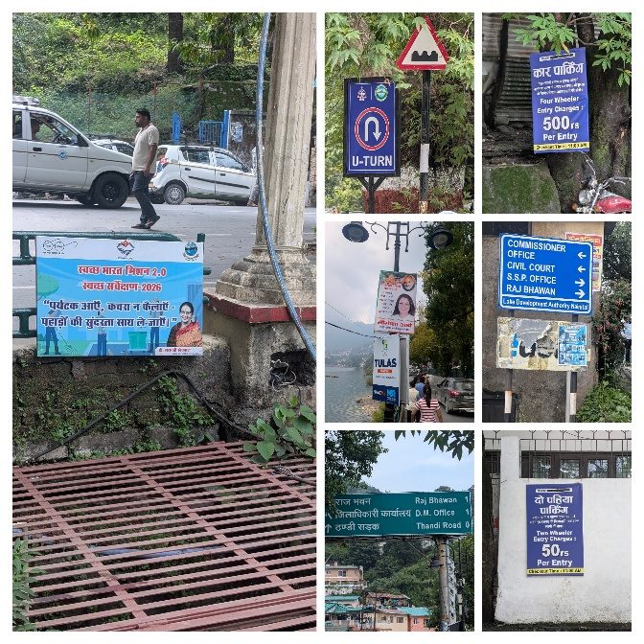
There is a laminated blue-and-white board with Hindi and English directions and clear arrows at eye level next to the Commissioner's Office, the Civil Court, the SSP Office, and the Raj Bhawan. The green highway format sign for the D.M. Office, Raj Bhawan, and Thandi Road is fully bilingual and includes distance information. Visually striking, double-sided paid-parking notices are laminated and bilingual, priced at 500 rupees for four-wheelers and 50 rupees for two-wheelers. Standard traffic signage and a private university advertisement panel are kept clean, lit and maintained. These boards don't make it clear that they're for tourists. The only reason most tourists go to the SSP office is that it is under scrutiny. It is under scrutiny, which is why most tourists go to the SSP office. They all serve the state's administrative navigation, or they collect (or receive payments from) for the space or are members of a political party that paid for it.

Neglected tier.
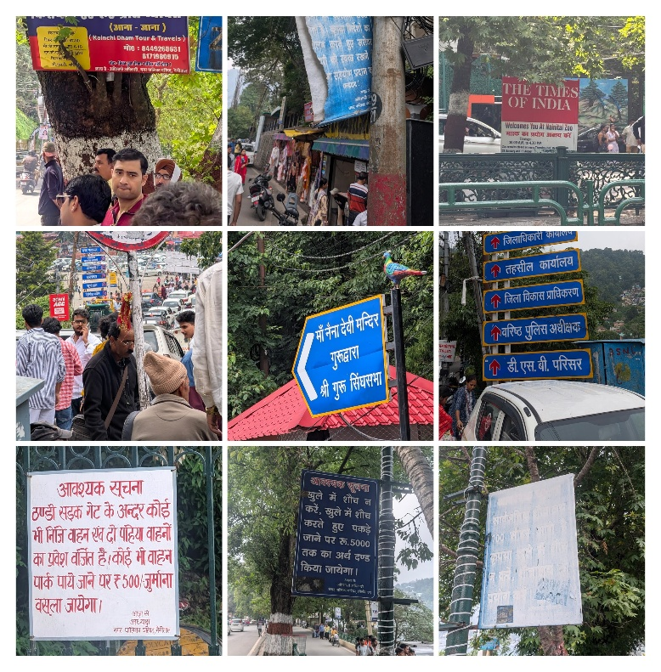

A blue municipal board along the lake shore has deteriorated to the point where no text is visible. A municipal Council notice on the open defecation fine is printed on dark blue paper in dense Hindi, which is quite difficult to read, with not a single word in English. The inscription ‘Vehicle Entry Prohibited’ on Thandi Sadak informs inhabitants that they can be fined 500 rupees if they try to use their vehicles there. It has a stack of directional signage for the D.M. office, the Tehsil, the SSP, the DSB campus, and the District Development Authority, with only part of the signage visible being in Hindi, and a parked car blocking all the signs to the D.D.A. and DSB campus. The name of the most popular religious shrine of the lake, the Maa Naina Devi temple, appears in no other scripture or language other than Devanagari. The Swachh Bharat Mission 2.0 board, with a tourist slogan printed on it, ‘come, but do not spread garbage,' is set close to ground level, alongside a drainage grate, such that a tourist must bend over to read it. The well-maintained tier is bilingual, laminated, and visible, whereas the tourist-oriented tier, identical to the latter, is Hindi-only, faded, and added as an afterthought.

Policy commitments and ground reality
The Uttarakhand Tourism Policy 2023 contains three provisions that directly relate to what we observed in the field. It requires signage to be provided in both Hindi and English at multiple locations, along with Braille inscriptions on descriptive signage (UTDB, 2023, p. 38). It also requires signage and patrols in accident-prone areas, including viewpoints at hill stations and water bodies (p. 47). These are not merely recommendations to look good on paper as a policy, but specific commitments included in a notified state tourism policy.

Bilingual obligation is upheld and enforced voluntarily and irregularly. Government-paid parking notices and signage at government offices comply with regulations. The boards that regulate visitor conduct, known as the rule signs, environmental warnings and municipal orders, do not. The one thing that the state wants visitors to pay for is bilingual services. What it wants tourists to obey isn't.
There is no commitment to the Braille. There were no signs at the precinct addressing the differently abled or this city using braille, either in directional signs, descriptions, or safety or informational signs that we saw.

The most disappointing of the waterbody safety commitments are those relating to the waterbody itself. The most common paid service used by tourists is boating, with 74 per cent of surveyed tourists using it. However, we did not find any emergency contact signs at the boating access along the lake, depth and hazard signs at the lake's edge, or any information about where someone is in relation to the lake in an emergency.

The absent map
We did not find a map of the Naini Lake precinct at any of the main tourist entry points, the Mall Road approaches, the flats, or the lake's edges. None of the users of the tourists coming on foot is represented visually anywhere in the Naina Devi temple, flats, boating jetties, viewpoints, zoo, or Thandi Sadak.

Advertising louder than information

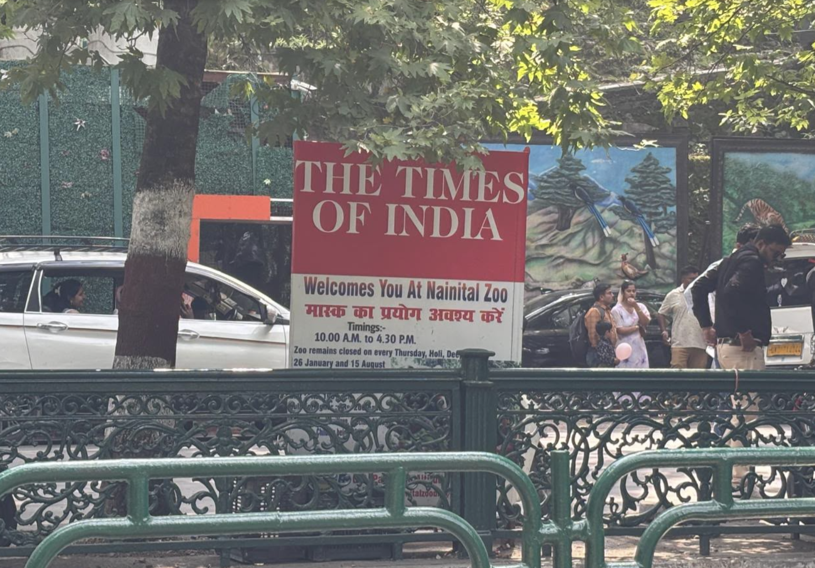

The Nainital Zoo is open from 10 AM to 4.30 PM. An important note: Thursdays and public holidays are zoo closure days. However, the top half of the board is in a vibrant red colour of the Times of India masthead. The real world, as a passing tourist sees it, is covered with the sponsor's branding, with the closure notice relegated to smaller text at the bottom. Anyone who was visiting on a Thursday could be forgiven for not noticing! That is not a lack of resources. The large, weatherproof panel was printed, installed and maintained by someone else. This is a lack of prioritising.

Waste segregation
Two types of dustbins are present in the Naini Lake area: paired dry- and wet-waste units in colour-coded bins, and single unmarked metallic bins where the paired units have not been installed. Neither type carries any pictogram showing what waste belongs where. The words "dry" and "wet" printed on the paired bins are not, in practice, an instruction. Tourists unfamiliar with the distinction have no visual aid to segregate correctly, and the outcome is predictably mixed waste.

Policy Recommendations
This field evidence shows that the problems in Nainital are not due to a lack of signage, but rather to the inadequate implementation of a proper tourist signage information system. Observations in the field revealed that the level of visibility, placement, language, accessibility and maintenance of signs indicating to tourists various points of the sites differs significantly from one another; Uttarakhand Tourism Policy 2023 provides for the presence of proper directional, informational, descriptive and tourist safety signage in Hindi and English at various locations across the sites, but also includes a provision for Braille signage on descriptive signage.
So the recommendations are centred upon standardising, accessibility, strategic positioning and ongoing monitoring of signage for the existing system, rather than just erecting more signboards.

1. Establish a Standardised Tourist Signage System for Nainital
The Nainital district administration, in coordination with the Uttarakhand Tourism Development Board and the Nainital Nagar Palika Parishad, can implement a uniform tourist signage system across the Naini Lake and Mall Road precinct. The emphasis needs to be on standardising the information boards – in terms of language, design, placement, visibility, and maintenance – rather than adding more without coordinated input.
The field observation revealed a wide spectrum of the quality of the signs. A few administrative and parking signs were bilingual, easily seen, and legible. At the same time, several that were directly relevant to tourists were not bilingual and had faded, were blocked, or scanned poorly. This demonstrates that not only must a signboard be present for it to be effective, but it must also be in the right form and location!
A universal signage system should be identified that incorporates informational, directional, identification, and safety or emergency signs. It needs to include considerations of font size, colour contrast, pictograms, mounting height, arrow shape, visibility, and positioning prior to key decision points.

2. Make Tourist Signage Inclusive and Safety-Oriented
Signage should be aimed at first-time visitors, with consideration for the needs of children, older visitors, and those with disabilities. This is important because repeat visitors found signboards more useful than first-time visitors (mean scores of 3.61 and 3.34, respectively).
The Uttarakhand Tourism Policy 2023 already provides for bilingual signage and Braille-enabled descriptive signage. It also specifically requests that signage and patrols be implemented in any area, such as a water body, that has experienced accidents. They should be translated into destination-level standards rather than at the policy level. This is in line with studies on universal design of tourist signage. Wan (2024) shows that signage is an extremely critical element when navigating routes with multiple turns and no directionality, particularly for the older population, people with disabilities, and family groups travelling with children. The accessibility framework in India also includes access to information, visual symbols, and alternative communication.
Priority should be renewed on Naini Lake and the boating areas. No signage was observed indicating an emergency contact at the boating access points, depth or hazard cautioning along the lake edges or location reference information for the visitor to use in an emergency. This is important because boating is the most-used paid service among surveyed tourists.

3. Develop a Continuous Pedestrian Wayfinding Network
A wayfinding network should not be a series of individual signboards in Nainital, but must be continuous. The field observation indicates that signage was more focused in the areas around Naini Lake, whereas information was available in certain areas around Mall Road and approaches. In particular, no maps of the Naini Lake precinct have been provided at major tourist entry points. A tourist pedestrian wayfinding audit should be carried out to determine the routes and decision points most frequently used by tourists, helping visitors be continually assured of their direction, rather than having to find a sign at any one time.
Major sightseeing places should be linked via the network, such as Naini Lake, Naini Mall Road, Flats, Thandi Sadak (Rajamandir), and the Nainital Zoo, along with other viewpoints. In addition to the major entry points and high-foot-traffic areas, orientation maps should be placed. These should include a clear "You Are Here" marker, main attractions, tracks for walking, legroom and amenities - toilets, car park, boating points, emergency/help areas, etc. Studies of public tourism wayfinding have shown that continuity and spatial arrangement are key factors in visitors' satisfaction with signage systems.
QR codes could be used to enhance information boards for selected attractions, facilities, local rules and events. QR-based information is not a replacement for vital safety, direction, or emergency information, however.

4. Introduce a Baseline Inventory, Signage Audit, and Accountability Mechanism
The "hole in the field" identified during fieldwork should be monitored and maintained regularly. The current policy has already recognised a commitment to installing water signage in both languages and Braille, and safety signage around water bodies, but field observations indicate this is not being achieved at ground level.
The initial action should be a one-off geo-referenced baseline survey of all of the tourist-facing signs in the precinct, documenting their location, language, type and condition. If there are no such standards, later assessments will be unable to measure improvement or changes in performance. After the baseline is established, a Nainital Tourist Signage Audit is to be carried out at least twice a year, and prior to the peak tourism seasons, for all signage in the Naini Lake and Mall Road precinct that serves tourists, using a standard checklist.
The audit is to evaluate primarily:
● Location: Where is the required sign located?
● Before relevant decision point – placement: Does it stand before the decision point?
● Is there any obstruction in sight?
● Readability: Does it give rise to any confusion or misinterpretation?
Are pages needed to provide bilingual information, and do they have it?
Are pictograms and Braille made available where necessary or appropriate?
Is there up-to-date information?
● Safety: Check if the required emergency/hazard signs are present or not?
For maintenance, does the sign need to be faded, damaged, and/or weathered?
● Continuity: Do the sign co-ordinates follow a logical sequence to the route to come next?
Each identified deficiency should be assigned to the appropriate enforcement agency, and the timeframe for the necessary changes should be outlined. Tourists and residents could also use a visitor-reporting system to bring missing, inaccurate, or damaged signs to the authorities' attention. This would place existing policy commitments onto destination management responsibilities, not as a one-off infrastructure intervention, and address the signage.

5. Require Pictograms on All Safety-Critical Signage
Use of Hindi and English is acceptable for reverse engineering in the policy, as per the general signage level of the standards, but is not permitted at a level critical to safety. The No. 1 national tourist who does not read Hindi and English, or who cannot read at all, is left exposed when the prize is greatest: when he visits Nainital.

For all pictograms that are safety-critical and include bilingual text, such as boating hazard warnings, emergency contact numbers, depth or slope indications, medical facility locations, and/or directions to escape, a pictogram with the internationally recognised ISO 7001 code or equivalent should be included. A good pictogram does not require language skills and makes no distinction about when people will understand it. The symbols used to mark toilets, parking, boating facilities, first aid, and help eggs should also use standard symbols, and, wherever possible, the core information should be readable in all languages so that all visitors clearly understand the basic concept.

Policy Direction
Results of the fieldwork indicated a positive and statistically significant correlation between the signboard's usefulness and overall tourist satisfaction (r = .321, p < .001). This implies that, though many signboards are installed, the usefulness and accessibility of tourist information are more important. Therefore, the policy response must be to improve the existing signage system, and not to treat signage as infrastructure only.

The suggested policy direction is towards the establishment of a uniform, user-friendly, perpetual and responsibility-based tourist information system of Nainital. This would translate the provisions of the Uttarakhand Tourism Policy 2023 into clear, reliable standards and monitoring mechanisms that tourists will find at the correct time, place, and format, and that will be maintained regularly. These measures become actionable through standardisation, inclusive, safety-based information, consistent pedestrian wayfinding, a minimalist, results-based audit, and the introduction of pictogram-based safety signage, while maintaining the current size of the tourist precinct by focusing on improving the safety, accessibility, and wayfinding of visitors' experiences and enhancing their tourist satisfaction.

Conclusion:
The present study on tourist signage in Nainital concludes that there is a significant disparity between the provisions of the Uttarakhand Tourism Policy 2023 and the needs of visitors to the Nainital area. There is not necessarily a shortage of information facilities, but existing signs are ineffective. The treatment of signs differs significantly: revenue-generating signs are kept in good condition and are served in two languages. In comparison, the administrative signs and signs important for visitors and environmental protection are well maintained and served in two languages. However, signs that are important for visitors and for environmental protection are often overlooked, hidden, or available only in Hindi. Overall satisfaction with the destination is positively and significantly related to the usefulness of the signage, as perceived by survey participants. This navigation challenge is more acute for visitors to a country for the first time, who rely most on physical cues to navigate. Although the policy requirements are clear and the number of tourists is high, the inclusion of essential hazard warnings, emergency contact details, and Braille accessibility is conspicuous in certain areas, particularly near water bodies, where high-risk activities occur. Lastly, the issue in Nainital is not due to the policy's design being wrong, but stems from the absence of police enforcement at the ground level and accountability measures. A growing tourist stream demands that destination management move away from a fragmented approach and establish an information network that is accessible, continuous, and visitor-focused. By incorporating standard bilingual signage, universal safety symbols, and robust auditing safeguards, Nainital can transform its passive signage into a dynamic, inclusive, and effective wayfinding system that truly helps its visitors.

References
ANI. (2026, June 27). Heavy footfall at Naini Lake and Mall Road as Nainital witnesses weekend tourism boom. ANI News. https://aninews.in/news/entertainment/out-of-box/heavy-footfall-at-naini-lake-and-mall-road-as-nainital-witnesses-weekend-tourism-boom20260627150640/
ETV Bharat. (2026, February 3). Uttarakhand records all-time high tourist footfall in 2025, crosses 6-crore mark. https://www.etvbharat.com/en/state/uttarakhand-records-all-time-high-tourist-footfall-in-2025-crosses-6-crore-mark-enn26020306415
Mitra, A. (2024). Modernising temple cities through smart signage: Enhancing urban tourism and visitor satisfaction: Case study: Varanasi. Urban India, 44(2), 91–109.
Moosavi, R., & Balraj, S. (2013). Understandability of tourism signage and travelers' satisfaction: Case of KLIA International Airport. In Signs and symbols in workplace and public.
Republic World. (2026, June 27). Nainital witnesses massive weekend rush, heavy footfalls at Naini Lake, Mall Road and other popular tourist spots. https://www.republicworld.com/travel/nainital-witnesses-massive-weekend-rush-heavy-footfalls-at-naini-lake-mall-road-and-other-popular-tourist-spots-2026-06-27-130196
Uttarakhand Paryatan Vikas Parishad. (2023, April 6). Office order regarding notification of the Uttarakhand Tourism Policy, 2023 (No. 88/2-7-306/2018 [Paryatan Niti]/2023). Government of Uttarakhand.
Uttarakhand Tourism Development Board. (2023). Uttarakhand Tourism Policy 2030. Government of Uttarakhand. https://uttarakhandtourism.gov.in
Wan, Y. K. P. (2024). Accessibility of tourist signage at heritage sites: An application of the universal design principles. Tourism Recreation Research, 49(4), 757–771. https://doi.org/10.1080/02508281.2022.2106099

